**LAB 6**

Question 1: Write a code to simulate Ping, Trace route Commands.

**PING**

import java.io.*;

import java.net.*;

class pingserver

{

public static void main(String args[])

{

try

{

String str;

System.out.print(" Enter the IP Address to be Ping : ");

BufferedReader buf1=new BufferedReader(new

InputStreamReader(System.in));

String ip=buf1.readLine();

Runtime H=Runtime.getRuntime();

Process p=H.exec("ping " + ip);

InputStream in=p.getInputStream();

BufferedReader buf2=new BufferedReader(new

InputStreamReader(in));

while((str=buf2.readLine())!=null)

{

System.out.println(" " + str);

}

}

catch(Exception e)

{

System.out.println(e.getMessage());

}

}

}

**OUTPUT**

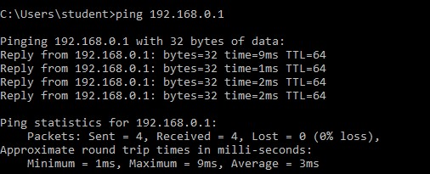

**TRACEROUTE**

import java.io.BufferedReader;

import java.io.InputStreamReader;

public class traceroutecmd

{

     public static void runSystemCommand(String command)

     {

          try

          {

              Process p = Runtime.getRuntime().exec(command);

              BufferedReader inputStream = new BufferedReader(

                        new InputStreamReader(p.getInputStream()));

              String s = "";

              while ((s = inputStream.readLine()) != null)

                   System.out.println(s);

          }

          catch (Exception e)

          {

          }

     }

     public static void main(String[] args)

     {

          // String ip = "www.google.co.in";

          // String ip = "127.0.0.1";

          String ip = "www.cp-algorithms.com";

          runSystemCommand("tracert " + ip);

     }

**OUTPUT**

